Business Time

[14 APRIL 2016 on Static Websites (/tag/static-websites/), Level 2 (/tag/level-2/), Project (/tag/project/)](https://coursework.vschool.io/tag/project/)

You just decided to start a business. You know you need a website, but you're bootstrapping your business without external funding, so you can't pay someone else to do it.

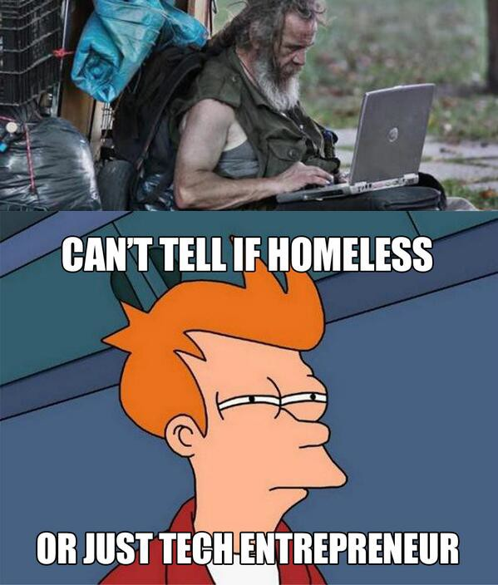

The type of business doesn't really matter, so get creative with it. This will be a static website, so it doesn't require the use of any JavaScript. However, if you want to go above-and-beyond, you're welcome to include some JavaScript too.

Your site should be well-styled and should look good on mobile screens (that is, it should be *responsive*).

Project Requirements

Create a website for your new business that is well-styled, responsive, and includes at least the following items:

Inline/Block elements Divs & spans

Images

List (navigation bar can count as a "list") Headers/paragraphs

[Semantic HTML (HTML 5 new tags (http://www.w3schools.com/html/html5_new_elements.asp)](http://www.w3schools.com/html/html5_new_elements.asp))

CSS Box model (margin, padding, border, width/height

Responsive (Media queries, Flexbox, Bootstrap Grid, CSS Grids, or any combination of the above)

Multiple HTML pages, linked

Passing Criteria: Class Demo

You'll be showing off your website and explaining your new business venture to the class. This demo will be short, probably only 1-2 minutes each.

This project passes off the following levels of the Skills Tree:

Static Websites, Level 2